Lead Testing Initial Test Results
We received the results from the first round of lead testing. In accordance with statute, these results are being communicated to parents and staff.
Number of Samples tested | 68
Number of Samples with lead Detected | 9
Percentage of Samples with Lead Detected | 13.2%
Number of Samples with lead Detected Above the Program Remediation Trigger | 3
Percentage of Samples with Lead Detected Above the Action Level | 4.41%
Immediate actions:
In accordance with guidance from the EPA, the affected faucets or outlets should have signage placed to indicate it is non-potable, not for drinking, or washing dishes. This signage can be temporary since testing is still in progress to localize the source of lead contaminants. The EPA allows for continued usage of outlets with a daily flush 3-5 minutes-prior to use.

Only three outlets were above the action level of 5 parts per billion, all three are outside spigots labeled as follows:
Follow-up Flush Plan for KCIA

KCIA-OUTSIDE-GRDN-SPGT | 11.8ppb
KCIA-OUTSIDE-RMP-SPGT | 7.12ppb
KCIA-OUTSIDE-FRNT-SPGT | 5.36ppb

All should have signage placed to indicate it is “non potable” until testing and remediation is complete.
Next steps:

Follow up flush samples will be collected per EPA and DHSS testing guidelines. Scheduled for October17th, 2023.
Health:
Kansas City Health Department
www.kcmo.gov
2400 Troost Ave, Kansas City, MO 64108 (816) 513-6008

Additional information and resources on the health effects of lead contamination are available here:
https://www.epa.gov/ground-water-and-drinking-water/basic-information-about-lead-drinking-water#health
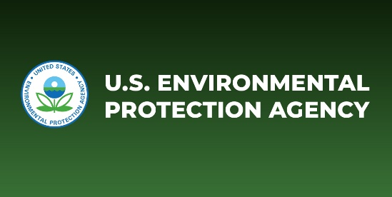 | Basic Information about Lead in Drinking Water | US EPA  Questions and answers about lead in drinking water -- health effects, EPA regulations etc.  www.epa.gov
Lab report and flush sampling plan are available on the school website.
Testing criteria:
Each sample was tested for total lead content which includes dissolved and particulate. The elevated level is defined as a level of lead ≥ 5pbb. Sampling was conducted per EPA test guidelines by initial draw after stagnation (periods of non-use that exceed eight hours). This manner of testing is the first step in localization and is paired with follow-up flush testing to further localize the source of any elevated levels.
Remediation:
These are efforts to mitigate and correct the levels of lead to which children and staff are exposed: The remediation plan will be posted when follow-up flush testing results are received and fiduciary constraints as well as maintenance availability have been considered.

